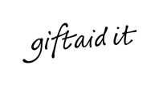
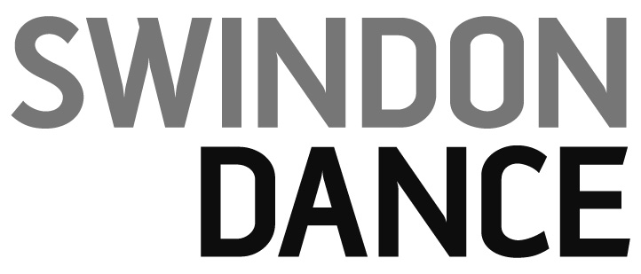

Title First name Surname

Address

Postcode

I confirm I have paid or will pay an amount of Income Tax and/or Capital Gains Tax for each year (6 April to 5 April) that is at least equal to the amount of tax that all the charities or Community Amateur Sports Clubs (CASCs) that I donate to will reclaim on my gifts for that tax year. I understand that other taxes such as VAT and Council Tax do not qualify. I understand Swindon Dance will reclaim 25p of tax on every £1 that I give.

Please claim Gift Aid on all qualifying gifts of money made (please tick all the boxes that apply):

today in the past 4 years in the future

Signature Date

Please remember to let us know of any changes to your tax status including changes to your name or address or if you need to cancel this agreement.

