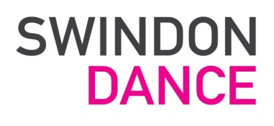

APPLICATION FORM

Please complete all sections of this form and return to sarah.ferris@swindondance.org.uk

- Post applied for:

2. Surname: Forenames:

3. Your address:

Home Tel:

Work /Daytime Tel:

Email Address:

4. Where did you hear about this vacancy?

5. Please refer to the Job Description and personal specification to tell us why you think you are a suitable candidate for this post and what skills, qualities and experiences you can bring to Swindon Dance. Please continue on an additional piece of paper if necessary.

6. Details of current / last employer (or contract if freelance) – if any:
Employer:
Address:

Start Date: End date, if relevant:

Position:

Duties:

Current Salary:
Reason for leaving:

7. Previous Employment:
Dates | Employer | Position and Main Duties:

8. Relevant Education and training:

Date | Details | Qualifications (if any) obtained

9. Professional Qualifications and memberships:

Date | Details | Qualifications, where applicable

10. Please list two people whom we may approach for professional reference, one of these should be your current employer, (if applicable):
1. Name: 2. Name:
Position: Position:
Address: Address:
Tel: Tel:
Are we able to approach these referees prior to interview: YES / NO*
*Please delete as applicable
11. If appointed, when would you be able to start work?

SIGNED: DATE:

Swindon Dance is committed to the application of equal opportunities principles in all its practices regarding the recruitment of staff.

CLOSING DATE: 15th August 2018 (5pm)
Please return to: sarah.ferris@swindondance.org.uk

