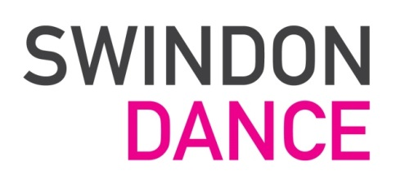
Person Specification

Essential
- A Minimum of 1 years’ experience of project management and coordination skills
- Excellent verbal and written communication skills
- Excellent time management, planning and organisational skills
- Excellent IT skills including Microsoft Office and Excel spreadsheets
- Safeguarding and Child Protection awareness

Desirable:
- Knowledge and awareness of Children with learning disabilities
- Knowledge and experience of the Arts and it’s ability to transform lives

Personal Qualities:
- A team player
- Ability to work on own initiative- a self starter
- Organised and professional
- Able to manage multiple priorities
- Committed to the ethos of Dance in the Community

Other requirements
- Enhanced DBS
- Emergency First Aid would be desirable

Swindon Dance is committed to the application of equal opportunities principles in all it’s practices regarding the recruitment of staff. Swindon Dance is committed to safeguarding and promoting the welfare of children, young people and vulnerable adults and expects all staff and volunteers to share this commitment.

This post may require some unsociable hours

