GUIDANCE NOTES FOR FILMING AND SUBMITTING YOUR FOOTAGE
As part of your application process, we are asking groups to send both a written application and digital footage of their piece to Swindon Dance by 5pm on Friday 2nd December 2016 (see application form for where to send it to). We do not expect to see complete, polished pieces of work however we would like to view it as near to finish as possible or real ideas for the work with the dancers who will be performing.

Groups will be judged by an independent panel on the criteria for the dance piece and not the quality or edit of their footage, however please follow these Do’s and Don’ts to ensure that your footage shows your dance piece as best it can.

HOW TO SEND YOUR FOOTAGE

There are a few options for how to send your footage to us:
- URL link (e.g. YouTube or Vimeo link)
- WeTransfer (See guidelines below on how to use this)

FILMING YOUR DANCE PIECE

Do’s | Don’ts
Do make sure that your dance piece and group are well lit and so are clearly visible. | Don’t film in the dark.
Do make sure that you film the piece in a clear space (no bags or  chairs around the edges). | Don’t distract the panel with clutter in the room - they may be mistaken for props.
Do make sure that your full group are present on the day of filming (or as close to all). | Don’t film a piece that should have 20 dancers with only 2 present.
Do make sure that the music can be heard. | Don’t use a phone to play music out of whilst filming - a sound system/stereo is much better. Don’t have the public chatting in the background.
Do make sure that you film the piece from the front | Don’t film the piece from the side or back of the dancers
Do make sure that when played on a PC the footage plays the correct way up and not on its side (you may need to change the orientation that you film it). | Don’t forget to test this – you’d be surprised how many times we watch footage with our heads at a funny angle!
Do try to make sure that the piece is as close to finished as possible. Although we do understand that some dance pieces may  be ‘works in progress’ when you apply. | Don’t just submit small clips of the piece on their own- it is hard for the panel to picture what the final piece will look like if they only seen this and have no information about what the finished piece will look like.
Do back up your application with notes and information about the piece. This could include what your plan is for the rest of the  piece, what the costumes will look like, how the piece will be staged, how the piece fits together | Don’t forget to help our panel picture what it will look like when  finished if submitting an unfinished or ‘work in progress’ piece
Do make sure that there is a clear start and clear finish | Don’t have the dancers stood chatting casually at the back  (unless this is part of your piece)

SUBMITTING YOUR DANCE PIECE

Do’s | Don’ts
Do check that URL link / We Transfer file works before sending | Don’t just send it in without checking it works
Do check that we have received your footage/application if you  do not hear from us | Don’t feel like you are pestering us, we would rather make sure  that all applications come through successfully
Do send any passwords that we need to be able to view your  URL link (if a private YouTube link) | Don’t make your footage so private that our panel cannot watch  it
Do Name your digital file or clip | Don’t leave it to us to guess which is your piece
Do email us if you have any questions | Don’t let footage submission be stressful and confusing

WE TRANSFER GUIDE FOR PC’S/LAP TOPS

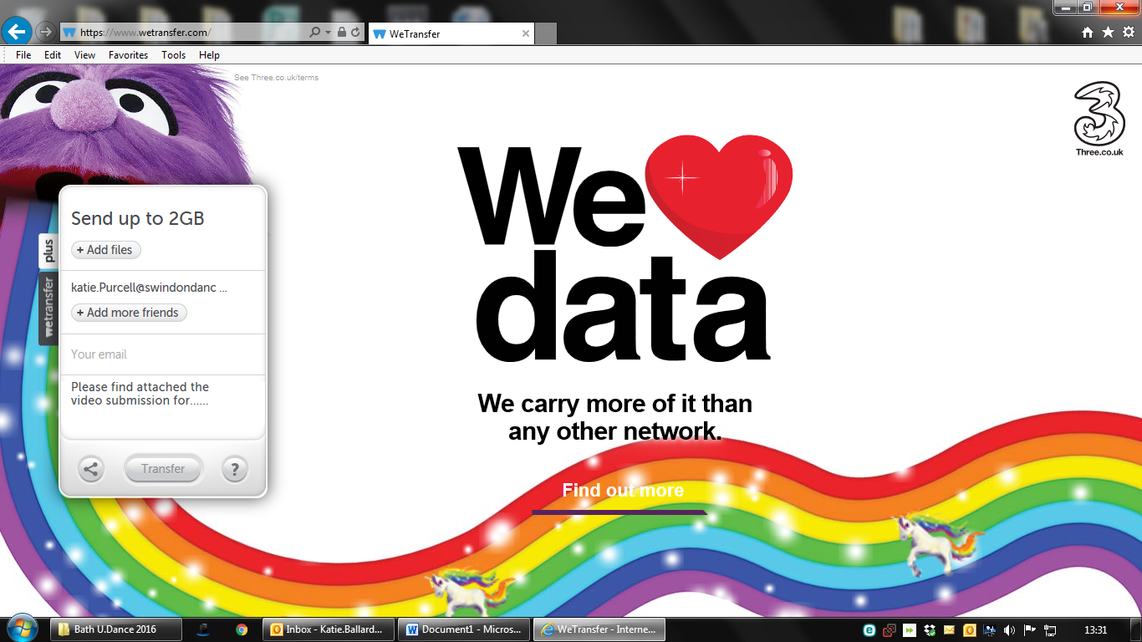
- Go to wetransfer.com
- When you see the above options select the file you would like to send
- Type Katie.Purcell@swindondance.org.uk as the ‘friend’s email’
- Type your contact email address
- Write a message letting us know what dance company you are sending from and the Title of your piece.
- Select ‘Transfer’

